# File permissions in Linux

## Project description

Through the Linux commands used in this project, I want to change and manipulate the access privileges of the user, the group, and other, which are types of users. By doing this I ensure that information is secure and can be accessed only by users who need it.

## Check file and directory details

To check the file and directory permissions, I used the command “ls -la”, which displays all the files and subdirectories, including user, group, and other permissions to read, write and execute the files/directories:

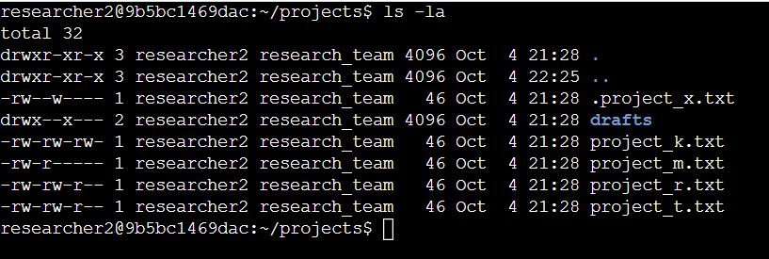

## Describe the permissions string

For example, the permission string for the file “.project_x.txt” indicates, firstly by the first character, that it is a file, then three batches of three characters describe the user, group, and other permissions. The user has read and write privileges, and the group only has write permissions. Other users don’t have any access to the file.

## Change file permissions

The organization does not allow other to have write access to any files. We notice that the file named “project_k.txt” allows this. We need to run the command “chmod o-w project_k.txt” to eliminate the write access to other users, followed by the previous command “ls -la” to visualize the change made.

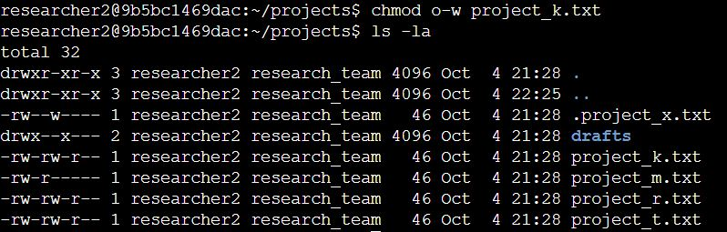

## Change file permissions on a hidden file

Similar to changing permissions for a normal file, I ran the command “chmod u-w,g=r .project_x.txt” which does the following: it revokes write privileges from the user, and “g=r” assigns exactly only read privileges to the group. The “ls -la” command serves to verify the correct use of the last command.

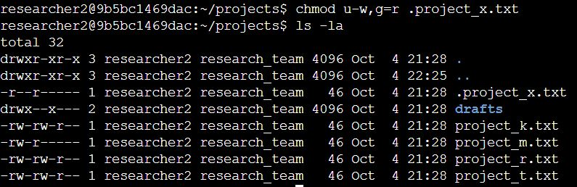

## Change directory permissions

Changing permissions for a directory is done in the same way. I ran the command “chmod g-x drafts/” which eliminates execute privileges from the group so that only the user can access its contents. The “ls -la” command verifies the correct use of the last command.

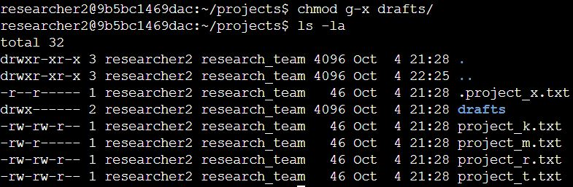

## Summary

In conclusion, I checked the current permissions and found that some of them were not properly configured. I changed permissions on a file as well as a hidden file and erased execute privileges off of a directory for a certain type of user.